Candidate Number

Please stick the barcode label here.

Marker’s

Use Only
 |  | Marker No.
Question No. |  | Marks
1
2
3
4
5
6
7
8
9
10
11
12
Total

ARISTO EDUCATIONAL PRESS

HONG KONG DIPLOMA OF SECONDARY EDUCATION EXAMINATION

ECONOMICS PAPER 2
(Mock Test 29)

Question-Answer Book

Time allowed: 2 hours 30 minutes
This paper must be answered in English

INSTRUCTIONS
- After the announcement of the start of the examination, you should first write your Candidate Number in the space provided on Page 1 and stick barcode labels in the spaces provided on Pages 1, 3, 5, 7, 9, 11, 13, 15, 17, 19, 21 and 23.
- This paper consists of three sections, A, B and C. Answer ALL questions in sections A and B. Attempt any ONE question in section C.
- Write your answers in the space provided in this Question-Answer Book. Do not write in the margins. Answers written in the margins will not be marked.
- Supplementary answer sheets will be supplied on request. Write your candidate number, mark the question number box and stick a barcode label on each sheet, and fasten them with string INSIDE this book.
- No extra time will be given to candidates for sticking on the barcode labels or filling in the question number boxes after the ‘Time is up’ announcement.

Section A (44 marks)

1. A popular Hong Kong music group held a concert in 2022. Tickets were publicly sold through URBTIX requiring real-name registration. When the tickets went on sale, a large number of people flocked to the website for the tickets. Many people said that they were unable to access the website until after the tickets had been sold out.

(a) Suppose the waiting time to access the website for two people who have bought the tickets is the same. Would their costs of buying the tickets at the same price necessarily be the same? Why?
(3 marks)

(b) By using real-name registration for ticket sales, ticket buyers must provide their full names in English as shown on a valid Hong Kong identity document when buying the tickets, and they must also present their identity documents with the same names stated on the tickets when entering the venue.

(i) ‘It is fairer to sell the tickets using real-name registration.’ Explain whether this is a positive statement or a normative statement. (2 marks)

(ii) Will the private property rights for the ticket owners over the tickets be weakened using real-name registration? Explain. (3 marks)

2. Mr. Chan operates a tutorial center in the form of a sole proprietorship. He is considering expanding his business.

(a) Mr. Chan plans to introduce new shareholders and run the tutorial center as a private limited company. List ONE advantage and ONE disadvantage of the change in the business ownership. (2 marks)

(b) After hiring more tutors, Mr. Chan found that all classrooms are fully booked and the marginal product of tutors has dropped. State the law that explains this phenomenon and briefly explain why this law can be applied to this case. (5 marks)

(c) The wages of the tutors of the tutorial center are calculated based on the number of students, but Mr. Chan has found that the turnover rate of the tutors is high. Suggest ONE wage payment method that Mr. Chan can adopt to reduce the turnover rate of the tutors as well as to improve their teaching quality. Briefly explain your answer. (2 marks)

Please stick the barcode label here.

3. In June 2022, online shopping platform HKTVmall opened its fourth physical supermarket in Ma On Shan, which is currently the largest HKTVmall supermarket. In addition to the provision of supermarket retail services, the supermarkets also serve as pick-up points for consumers who have ordered goods from the HKTVmall online platform.

(a) HKTVmall has expanded its business from an online shopping platform to a physical supermarket. Explain TWO possible advantages of such an expansion for HKTVmall. (4 marks)

(b) HKTVmall supermarkets only accept electronic payment, and cash payment is not accepted. Explain which function of money cash fails to perform in this case. (2 marks)

4. The Hong Kong Science Museum is staging a dinosaur exhibition from July to November 2022, showcasing precious fossil skeletons and other fossil materials from dinosaurs. Admission to the exhibition is free.

(a) To the Hong Kong Science Museum, explain whether the exhibits are consumer goods or producer goods. (2 marks)

(b) Explain whether the exhibits are free goods or economic goods. (2 marks)

Please stick the barcode label here.
5. The table below shows the balance sheet of a banking system. The public do not hold cash and the banks hold $1,000 million of excess reserves.

Assets ($ million) | Liabilities ($ million)
Reserves 4,000  Loans 11,000 | Deposits 15,000

(a) (i) Find the required reserve ratio. (1 mark)

(ii) State ONE possible reason that banks hold excess reserves. (1 mark)

(b) A person withdrew $2,000 million from the banking system. Half of the amount is held in cash and the remainder is remitted overseas. Suppose the banks are fully loaned up. Calculate the change in the money supply. Show your working. (4 marks)

6. (a) ‘Inflation will occur when the total output of an economy is growing slower than the money supply.’ Explain this statement in terms of the quantity theory of money. (4 marks)

(b) Explain why the nominal interest rate is higher than the real interest rate when there is expected inflation. (2 marks)

Please stick the barcode label here.
7. The following table shows the production and consumption data of Country A.

 | Butter (units) |  | Jam (units)
Total output without specialisation and trade | 50 | AND | 20
Total output with specialisation and trade | 0 | AND | 60
Total consumption with specialisation and trade | 45 | AND | 30

(a) Calculate the opportunity cost of producing 1 unit of jam in Country A. (2 marks)

(b) Find the terms of trade for 1 unit of jam. (2 marks)

(c) Calculate the gain per unit of exports for Country A. (1 mark)

END OF SECTION A

Section B (60 marks)

8. In order to improve its huge fiscal deficit, a country decides to impose a per-unit tax on all packages of rice (regardless of the package size). Suppose people’s demand for packaged rice is inelastic.

(a) (i) Explain whether the above tax is a direct tax or an indirect tax. (2 marks)

(ii) Explain whether the imposition of the above tax follows the tax principle of ‘equity’ put forward by Adam Smith. (2 marks)

(b) With the aid of a diagram, explain how the above tax would affect people’s total expenditure on packaged rice. (6 marks)

(c) Using the law of demand, explain why the average weight of packages of rice purchased by people would increase after the imposition of the per-unit tax. (5 marks)

Please stick the barcode label here.

9. The government announced that the Normal Old Age Living Allowance (Normal OALA) and Higher Old Age Living Allowance (Higher OALA) will be merged in September 2022. The merged OALA will adopt the more relaxed asset limits of the Normal OALA and the payment rate of the Higher OALA. Elderly persons who are currently receiving Normal OALA will switch to Higher OALA and will receive an additional amount of about $1,000 per month.

(a) Explain whether the amount of the Old Age Living Allowance paid by the government will be included in the calculation of Hong Kong’s gross domestic product (GDP). (2 marks)

(b) Discuss the effect of the above measure on Hong Kong’s income inequality. (2 marks)

(c) Suppose there is a deflationary (output) gap in Hong Kong’s economy. With the aid of an AD-AS diagram, explain how the above measure will affect the deflationary (output) gap in the short run.
(7 marks)

Please stick the barcode label here.

Please stick the barcode label here.
10. Railways play an important role in Hong Kong’s public transport system. The coverage of the railway network in Hong Kong has gradually been improved in recent years.

Source A: A news extract about the opening of the East Rail Line Cross-Harbour Extension
The MTR Corporation Limited (stock code: 0066) provides railway services in Hong Kong. The East Rail Line Cross-Harbour Extension opened on 15 May 2022 as the fourth cross-harbour railway line in Hong Kong. The cost of the East Rail Line Cross-Harbour Extension was about $91.5 billion, which was paid by the government. The MTR is responsible for the construction and the operation.
(Source: various newspapers)

Source B: Some basic information about the East Rail Line
The total length of the full East Rail Line is about 46 km. It is the fourth cross-harbour railway line after the Tsuen Wan Line, the Tseung Kwan O Line and the Tung Chung Line. Admiralty Station is the new terminal station, and the Exhibition Centre Station was newly constructed in the cross-harbour extension.

There are four interchange stations on the full line, connecting five other railway lines, namely the Tuen Ma Line, the Kwun Tong Line, the Tsuen Wan Line, the Island Line and the South Island Line. Admiralty Station is now a mega interchange station with four-line interchanging.
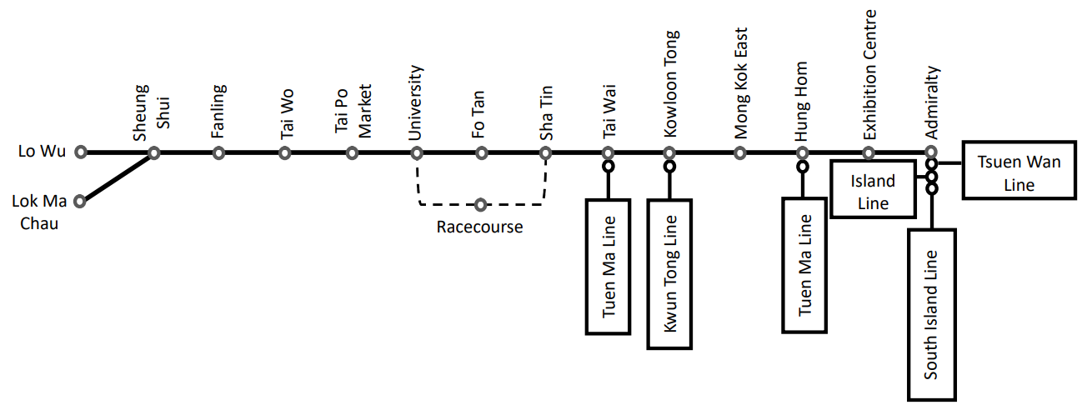

(Source: Official webpage of MTR Corporation Limited)

Upon the opening of the East Rail Line Cross-Harbour Extension, the number of bus passengers dropped by about 20,000 per day. The occupancy rate of the special departure of a cross-harbour bus route has dropped from the previous 70% to about 20%. The government will consider adjusting the bus service arrangements in stages according to the actual needs of passengers.
Source C: A news report about the change in the number of bus passengers upon the opening of the East Rail Line Cross-Harbour Extension

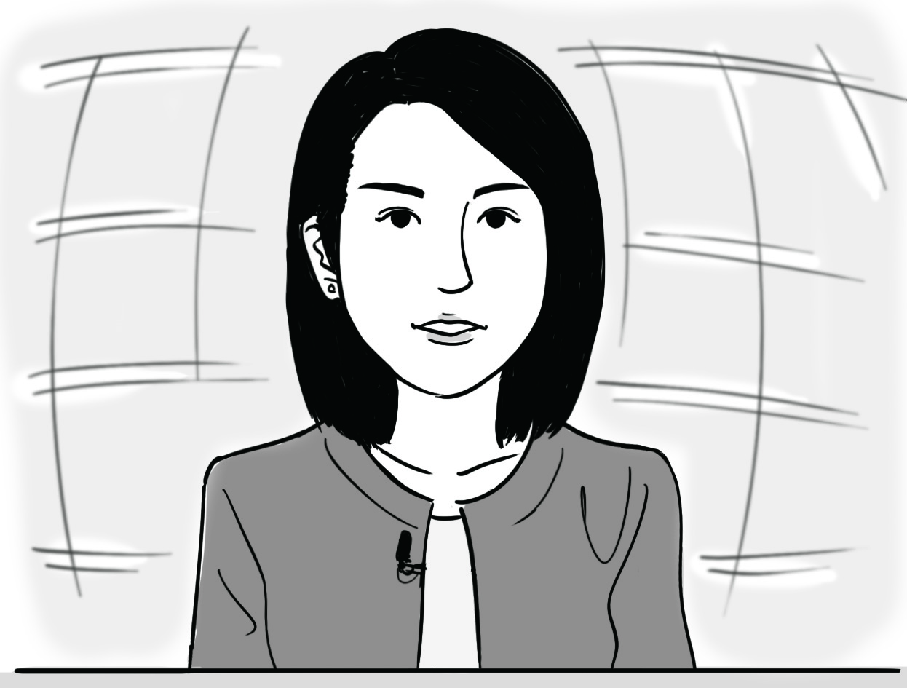

Source D: Some views on the opening of the East Rail Line Cross-Harbour Extension
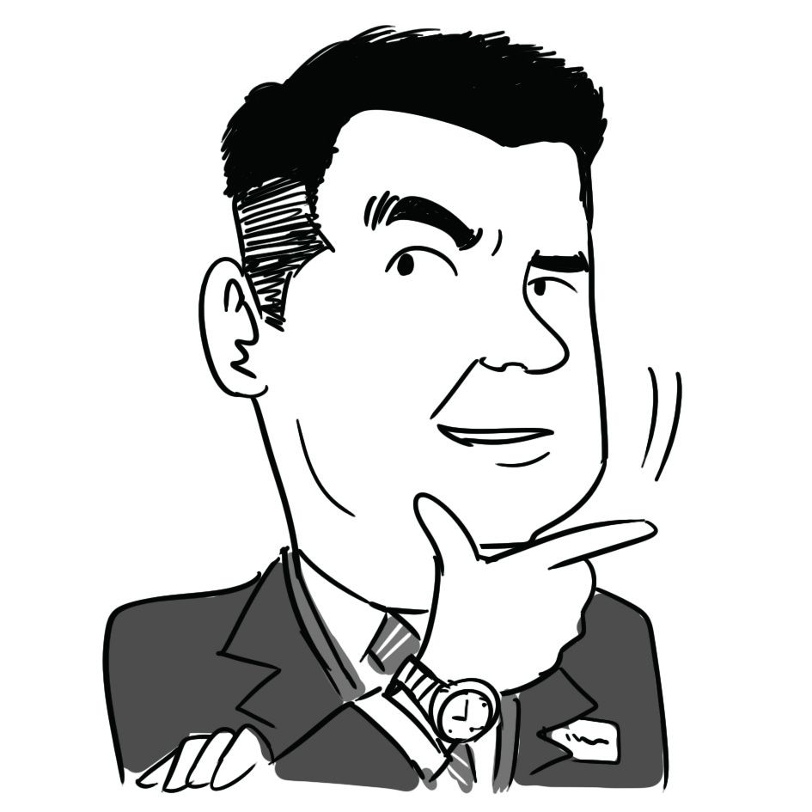  A commentator | Transport in the northern New Territories is being improved. Rentals and prices of both commercial and residential properties in this area are expected to increase.
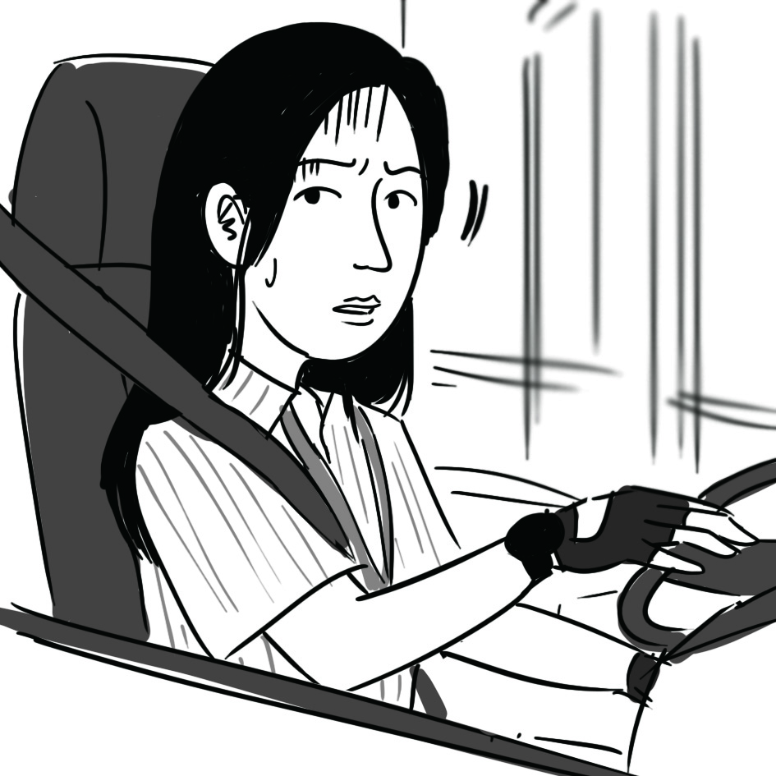  A bus driver | Many bus passengers may switch to the railway system upon the opening of the East Rail Line Cross-Harbour Extension. I fear my job may be affected.
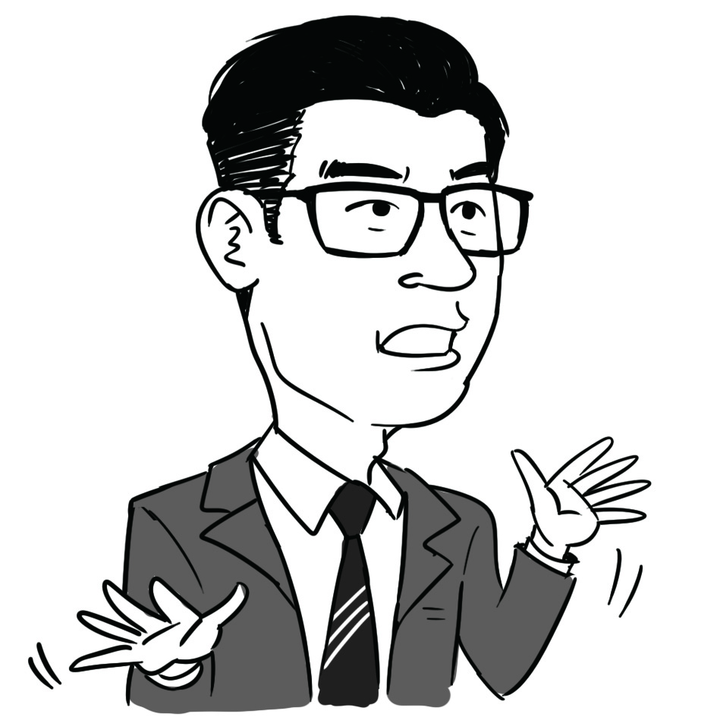  A bank worker | I live in Tai Po and I used to drive to work. In the past, I would not consider working on Hong Kong Island, but now I may consider it after the opening of the East Rail Line Cross-Harbour Extension.

Please stick the barcode label here.

(a) Refer to Source A. What type of business ownership does MTR Corporation Limited belong to? List ONE feature of this type of business ownership. (2 marks)

(b) Refer to Sources A and B. Discuss the effect of the full opening of the East Rail Line on labour mobility. (3 marks)

(c) Refer to Sources A and B. Other things being constant, how would the construction of the East Rail Line Cross-Harbour Extension affect Hong Kong’s aggregate demand and long run aggregate supply? What would be the effect on the output level in the long run? Explain your answer with the aid of a diagram.
(7 marks)

(d) According to Source C, there is a drop in the number of bus passengers upon the opening of the East Rail Line Cross-Harbour Extension. With the aid of a diagram, explain why the situation may be inefficient.
(5 marks)

(e) With reference to the view of the commentator in Source D, explain how the full opening of the East Rail Line may involve externality. (3 marks)

For part (f), candidates are required to present their answer in essay form. Criteria for marking will include use of sources and economic theories, relevant content, logical presentation and clarity of expression.

(f) Suppose the government has two suggestions for the public transport system in Hong Kong.

Suggestion I: Rationalise bus routes, including cutting bus routes with low occupancy rates
Suggestion II: Construct a new railway extension

With reference to the above sources and your own knowledge in Economics, discuss which suggestion the government will prefer in order to achieve EACH of the following policy objectives respectively.

Objective 1: to reduce people’s transportation costs
Objective 2: to increase government revenue in the future
Objective 3: to lower the unemployment rate
(14 marks)
(Use a separate paragraph for each policy objective, comparing the effects of the two suggestions.)

Please stick the barcode label here.

END OF SECTION B
Unit price
0
Quantity
D
MC: Marginal cost
D: Demand
Figure 1
MC
Section C (16 marks) Answer any ONE question.

11. The book retailing market in Country A is a monopoly. The book retailer adopts uniform pricing. Figure 1 shows its demand curve and marginal cost curve.

(a) Indicate the marginal revenue curve (MR), the profit-maximising output level (Q_{M}) and the price (P_{M}) of the book retailer in Figure 1. (3 marks)

(b) Later, the government open up the book retailing market. Many firms enter the market, and it becomes perfectly competitive.

(i) Indicate the new profit-maximising output level (Q_{C}) and the price (P_{C}) in Figure 1. (2 marks)

(ii) With the aid of Figure 1, explain how such a change in the market structure can improve economic efficiency. (4 marks)

(c) A book retailer offers a student discount. All students with valid student identification documents can purchase designated books at 30% off the original price. Explain whether this price arrangement constitutes price discrimination. (3 marks)

(d) It has been reported that several book retailers in the market have agreed to charge the same price for the books they sell.

(i) What kind of anti-competitive behaviour is described in the above practice? List ONE possible motive for it. (2 marks)

(ii) If the above case happened in Hong Kong, which conduct rule of the Competition Ordinance would the book retailers violate? Explain. (2 marks)

Please stick the barcode label here.

Please stick the barcode label here.
P_{B}
Clothing
0
Food
PPF_{A}
PPF_{B}
Figure 2
12. Refer to Figure 2. PPF_{A} and PPF_{B} are the production possibility frontiers of Country A and Country B respectively. Both countries have the same amount of resources. P_{B} is the production point of Country B before trade. The slope of the dotted line is the world price of clothing.

(a) Which country has an absolute advantage in producing clothing? Explain. (2 marks)

(b) Explain which country has a comparative advantage in producing clothing. (2 marks)

(c) Suppose both countries engage in complete specialisation according to their comparative advantages and trade. In Figure 2,

(i) indicate the production points of Country A and Country B after trade as P_{TA} and P_{TB} respectively.
(2 marks)

(ii) indicate the consumption possibility frontier (CPF_{B}) of Country B after trade. (2 marks)

(d) Suppose Country B consumes the same amount of food before and after trade. In Figure 2, indicate the consumption point (C_{TB}), export volume and import volume of Country B after trade. (3 marks)

(e) The following table shows some data of Country A and Country B.

 | Country A | Country B
Per capita GDP | $50 billion | $60 billion
Life expectancy at birth | 75 years | 80 years
Number of schools per 1,000,000 population | 150 | 100

(i) Based on the above information, which country do you think will have a higher Human Development Index (HDI)? Explain. (2 marks)

(ii) Give ONE possible reason to explain why HDI will increase after a country opens up to trade.
(1 mark)

(iii) Most citizens of Country B think that their living standard is lower than that of Country A. Give ONE possible reason to explain their view. (2 marks)

Please stick the barcode label here.
END OF PAPER

